**The following part (Lisp exercise) is not graded. Please do and study for your review and for test.**

**Lisp Exercise**

1. What is the parenthesis notation for this cons cell structure?

(1)

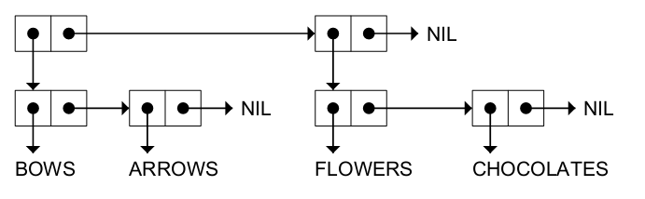

Answer:

(2)



Answer:

(3)



Answer:

(4)



Answer:

2. Draw the internal structure for the following list(s).

(You may draw your answer on a paper, scan or picture of it, and paste here)

(1) (RED GREEN BLUE)

(2) ((BLUE SKY) (GREEN GRASS) (BROWN EARTH))

(3) ((BRAIN SURGEONS) NEVER (SAY OOPS))

(4) ((PHONE HOME))

3. Consider the following list, and answer the following questions. (FIRST List) = (CAR List)

(CDR List) = (Rest List)

((BLUE CUBE) (RED PYRAMID))

|  |  |  |
| --- | --- | --- |
|  | Initial List for each problem | ((BLUE CUBE) (RED PYRAMID)) |
| 1 | CAR | (BLUE CUBE) |
| 2 | CDR | ((RED PYRAMID)) |
| 3 | CADR |  |
| 4 | CDADR |  |
| 5 | CADADR |  |

4. How many elements do each of the following lists have?

|  |  |  |
| --- | --- | --- |
|  | (length expression) where each expression is as follows | Answer |
| 1 | (OPEN THE POD BAY DOORS HAL) |  |
| 2 | ((OPEN) (THE POD BAY DOORS) HAL) |  |
| 3 | ((1 2 3) (4 5 6) (7 8 9) (10 11 12)) |  |
| 4 | ((ONE) FOR ALL (AND (TWO (FOR ME)))) |  |
| 5 | ((Q SPADES)(7 HEARTS)(6 CLUBS)(5 DIAMONDS)(2 DIAMONDS)) |  |

5. What do each of the following expressions evaluate to?

|  |  |  |
| --- | --- | --- |
|  | Expression | Result |
| 1 | (list 'cons t nil) |  |
| 2 | (eval (list 'cons t nil)) |  |
| 3 | (eval (eval (list 'cons t nil))) |  |
| 4 | (apply #'cons '(t nil)) |  |
| 5 | (eval nil) |  |
| 6 | (list 'eval nil) |  |
| 7 | (eval (list 'eval nil)) |  |

6. What is the result of the following Lisp expression?

|  |  |  |
| --- | --- | --- |
|  | (setf line '(roses are red)) | Answer |
| 1 | (reverse line) |  |
| 2 | (first (last line)) |  |
| 3 | (nth 1 line) |  |
| 4 | (reverse (reverse line)) |  |
| 5 | (append line (list (first line))) |  |
| 6 | (append (last line) line) |  |
| 7 | (list (first line) (last line)) |  |
| 8 | (cons (last line) line) |  |
| 9 | (remove 'are line) |  |
| 10 | (append line '(violets are blue)) |  |

7. What would be the (final) result of the following expression(s), or write a lambda expression for the expected result.

|  |  |  |
| --- | --- | --- |
|  | Problem | Result |
| 1 | (defun add1 (n) (+ 1 n))  (mapcar #'add1 '(1 3 5 7 9)) |  |
| 2 | (mapcar #'zerop '(2 0 3 4 0 -5 -6)) |  |
| 3 | (mapcar #'null '(0 1 T NIL () T)) |  |
| 4 | Write a lambda expression to subtract seven from a number. |  |
| 5 | Write a lambda expression that returns T if its input is T or NIL, but NIL for any other input. |  |

8. What would be the result of the following expression(s)? Answer in T or NIL.

|  |  |  |
| --- | --- | --- |
|  | (setf x1 (list 'a 'b 'c))  (setf x2 (list 'a 'b 'c))  (setf z x1) | Answer |
| 1 | (equal x1 x2) |  |
| 2 | (eq x1 x2) |  |
| 3 | (eq z x1) |  |
| 4 | (eq z '(a b c)) |  |
| 5 | (equal z '(a b c)) |  |
| 6 | (eql 'foo 'foo) |  |
| 7 | (eql 3 3.0) |  |
| 8 | (= 3 3.0) |  |
| 9 | (car NIL) |  |
| 10 | (cdr NIL) |  |

9. Briefly explain EQ, EQL, EQUAL, EQUALP, and = in Lisp

Answer